|  |  |  |
| --- | --- | --- |
|  | EUROPEAN COMMISSION  DIRECTORATE-GENERAL  INFORMATICS  Infrastructure and Logistics Directorate  **Technical solutions and office systems** | Digit |

**e-TrustEx Party Administration Tutorial**

|  |  |
| --- | --- |
| Date: | 21/04/2015 |
| Version: | 1.1 |
| Authors: | Armen Cholakian |
| Revised by: | Alexandru Tirdea and Valer Micle |
| Approved by: | Razvan Ionescu |

Document History

|  |  |  |  |
| --- | --- | --- | --- |
| Version | Date | Comment | Modified Pages |
| 1.0 | 31/01/2014 | Document created by Armen Cholakian |  |
| 1.1 | 21/04/2015 | - All screenshots updated to reflect new ECAS screen and user interface changes.  - Added instructions to edit a user.  - Added new SG support email address | all |
|  |  |  |  |
|  |  |  |  |
|  |  |  |  |

## Administering e-TrustEx Users (for local Party Administrators)

In your institution you need a local Party Administrator to administer users on behalf of your organisation.

The first local Party Administrator of your organisation is set-up by the Commission at the set-up of the e-TrustEx data flow. Once this person has been granted access, your organisation can administer users independently from the services of the Commission.

When adding users you have to assign them a "role". The role will define what usage rights they will have in the application. There are two types of role available:

**Operator** – this role allows you view the messages of your party (or parties) in the e-TrustEx application.

**Party Administrator** – this role allows you view the messages of your party (or parties) in the e-TrustEx application and also have the ability to grant Operator and Party Administrator roles to other users for your party (or parties) in the e-TrustEx application.

* To access the Party Administration screen click on the following link:

<https://webgate.ec.europa.eu/e-trustex>

* Log into e-TrustEx using your ECAS username and password.

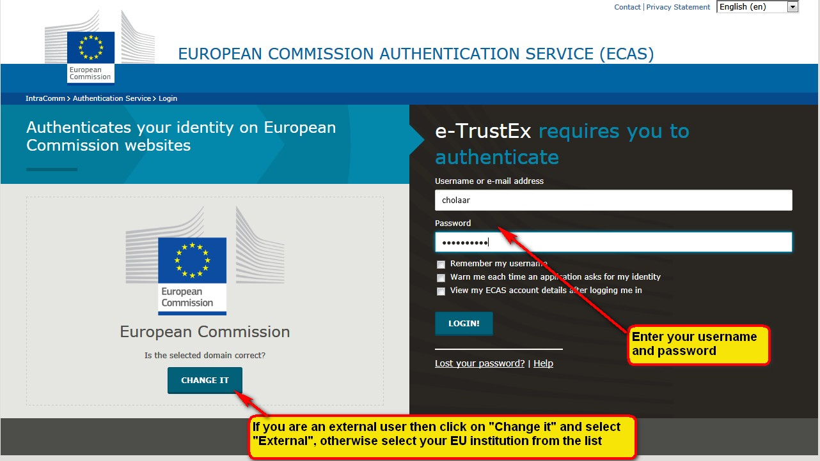

* After successfully logging in you will be directed to the Message Inbox of your e-TrustEx party.
* Click on the Administration link as shown below:

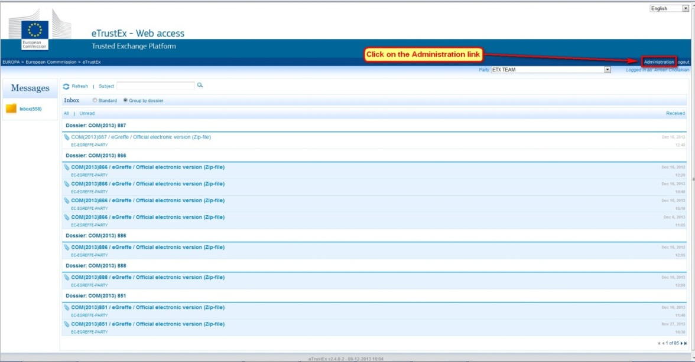

* You will be directed to the Administration page as shown below.
* In this example we will add a new Operator to the party called "DEV-ETX-ARMEN-PARTY". It is possible for a Party Administrator to have access to multiple parties – if this is the case for your user, you will see the party name in the form of a drop down list, otherwise you will only see your single party already displayed.
* Select the correct party you wish to Administer via the drop down list.

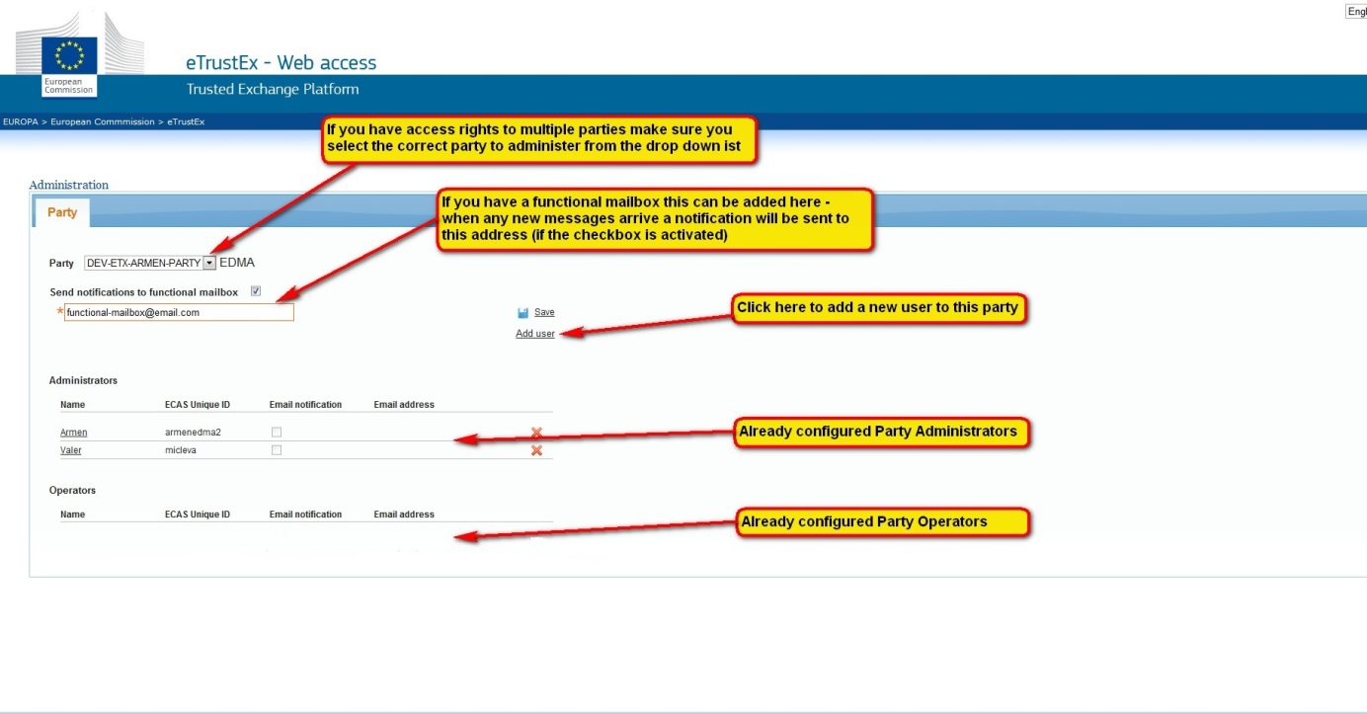

* **Add user** - Click "Add user" – a popup window will appear.
* Enter the full name of the user and the "Unique identifier at the Commission (uid)" as provided by the user. **Important** – the user must provide you the uid and not their login username (see the tutorial for creating an ECAS account for more information.
* Optionally you can also enter an email address – only if the user wishes to receive an email every time a new message arrives for their party. If yes, select the "Email notification" checkbox to activate the email feature. Finally click on "Add user" to confirm the new user action.
* Enter a role for the new user:
  + Operator – this role will allow you to view messages for the selected party
  + Administrator – this role will allow you to view messages for the selected party and administer the users of the selected party

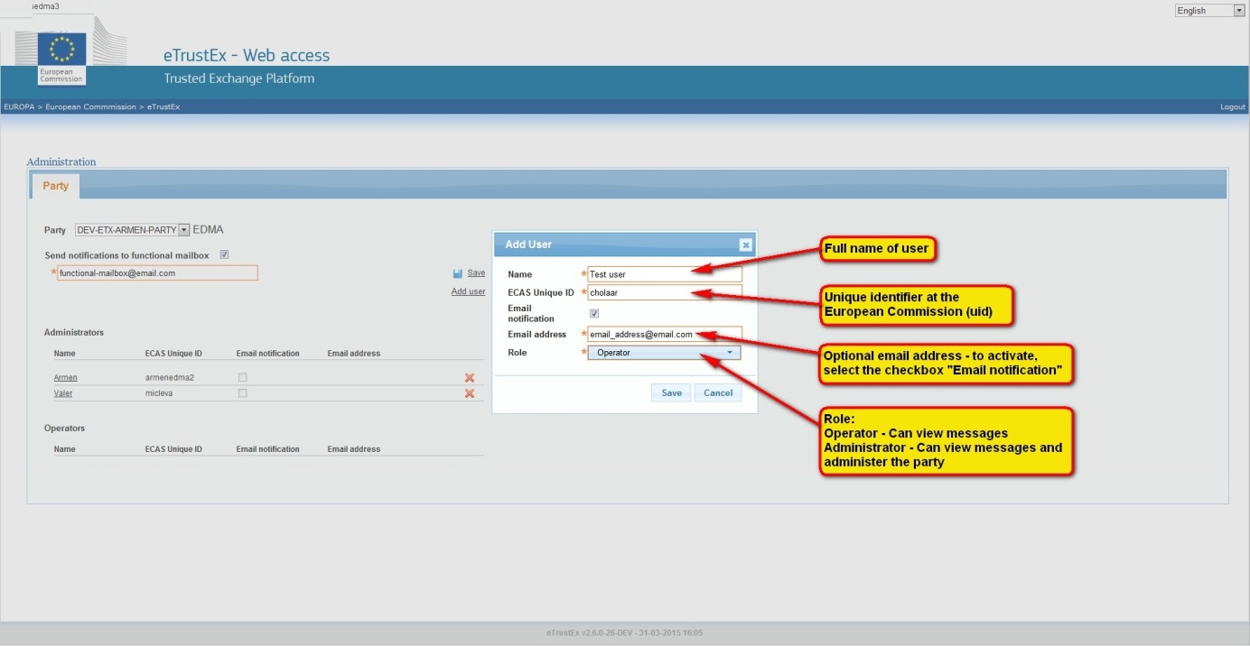

* After submission, the screen will be refreshed and the new user is added to the list of Operators. Note – any changes to the roles will be activated at the next login for that user.

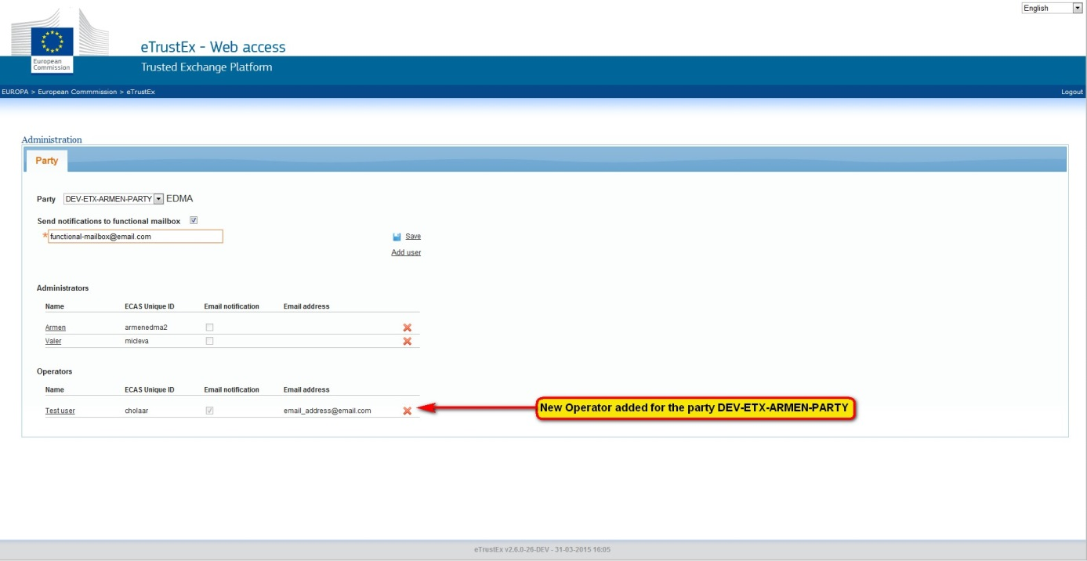

* **Edit user** – you can also modify some of the details of an existing user – for example you can change the name, change the role and also edit, activate or deactivate the email notifications for that user.

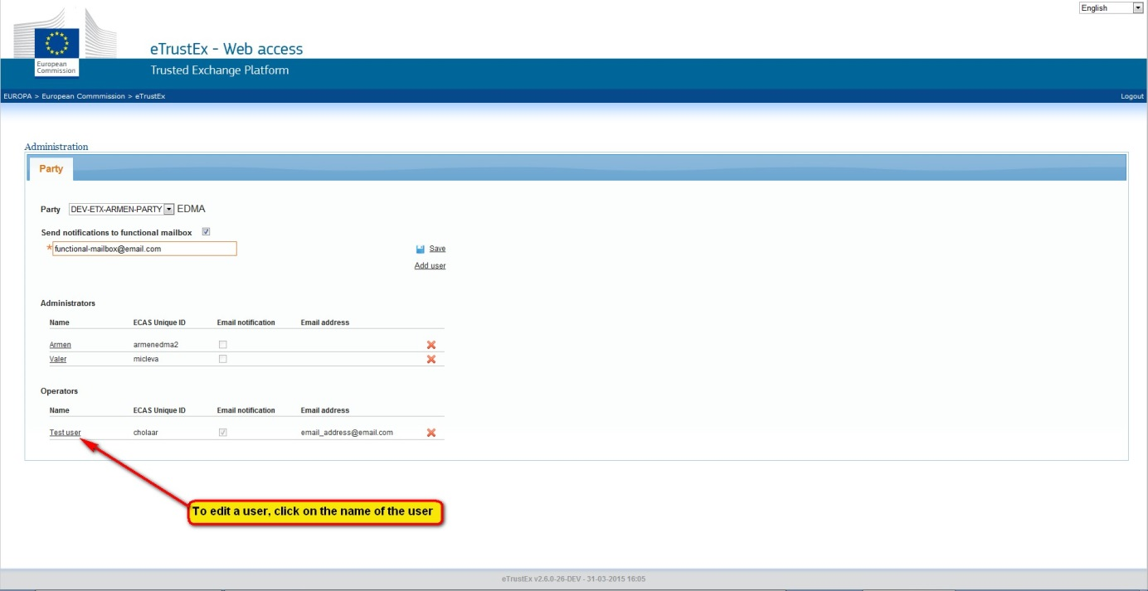

* To edit a user click on the Name of the user on the Administration screen. A popup will open and from here you can modify the values of the selected user.

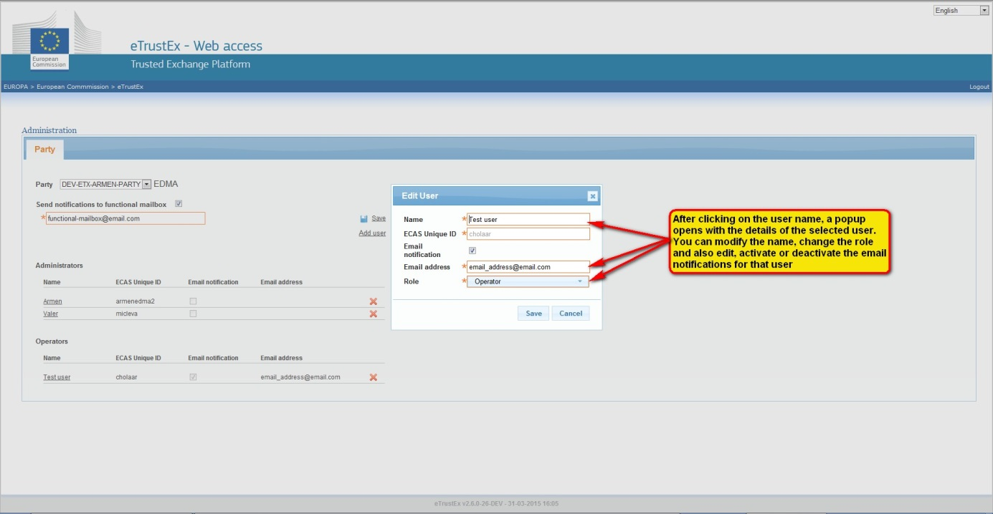

* **Delete user** - To delete a user click on the red cross icon to the right of the user. A pop up window appears to confirm the delete. Click on the "Remove" button to confirm the delete.

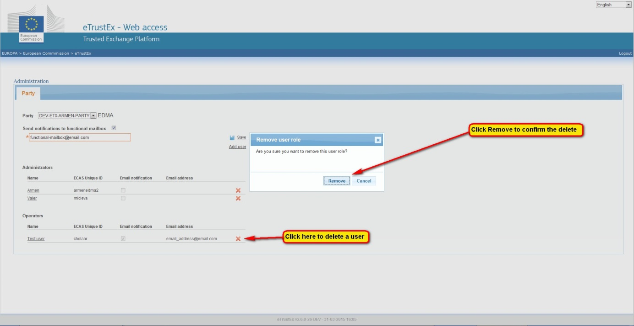

* After deletion the user is removed from the Administration screen.
* To return to the e-TrustEx Message Inbox click on the "eTrustEx" link as shown below.

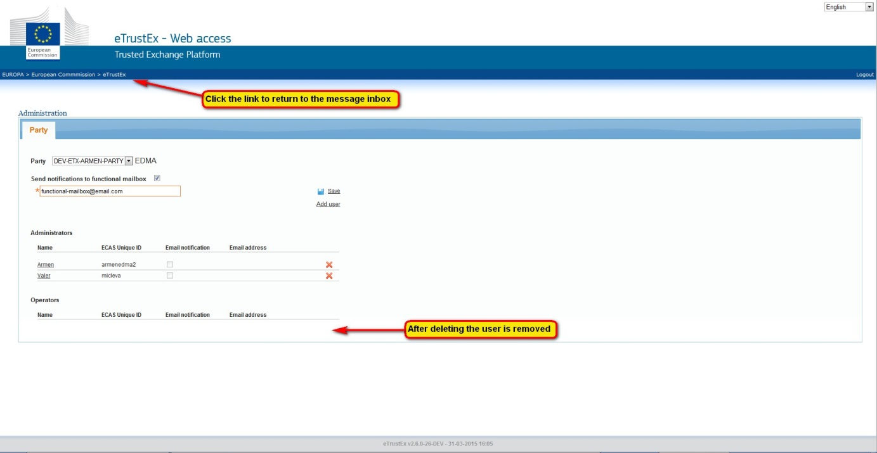

For any further information or technical assistance please contact us via the e-TrustEx support email address: [SG-DECIDE-DECISION@ec.europa.eu](mailto:SG-DECIDE-DECISION@ec.europa.eu)